SQL Exercise 1

1. Create the table SEMP with the following structure:-

EMPNO CHAR(4)

EMPNAME CHAR(20)

BASIC FLOAT(9,2)

DEPTNO CHAR(2)

DEPTHEAD CHAR(4)

2. Create the table SDEPT with the following structure:-

DEPTNO CHAR(2)

DEPTNAME CHAR(15)

3. Insert into the SDEPT table the following values:-

10, Development

20, Training

4. Insert into the SEMP table the following values:-

0001, SUNIL, 6000, 10

0002, HIREN, 8000, 20

0003, ALI, 4000, 10, 0001

0004, GEORGE, 6000, 0002

ANSWER:

create database Employee;

use Employee;

create table SEMP(

empno char(4),

empname char(20),

basic float(9,2),

deptno char(2),

depthead char(4)

);

create table sdept(

deptno char(2),

deptname char(15)

);

insert into sdept (deptno , deptname)

values ("10", "Development"),("20", "Training");

insert into semp (empno, empname, basic, deptno, depthead)

values ("0001", "sunil", 6000, "10", "0003"),

("0002", "hiren", 8000, "20","0001"),

("0003", "ALI", 4000, "10", "0001"),

("0004", "GEORGE", 6000, "20","0002");

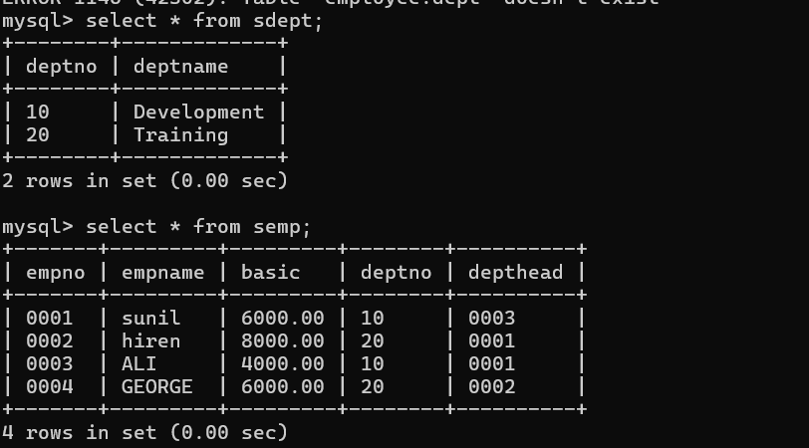

SQL Exercise 2

1. Display the Supplier table in the descending order of CITY.

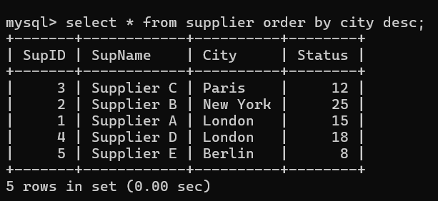

2. Display the Part Table in the ascending order of CITY and within the city in the

ascending order of Part names.

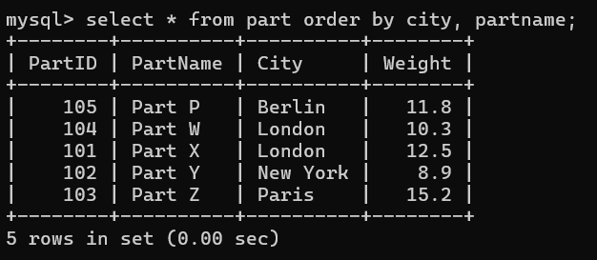

3. Display all the Suppliers with a status between 10 and 20.

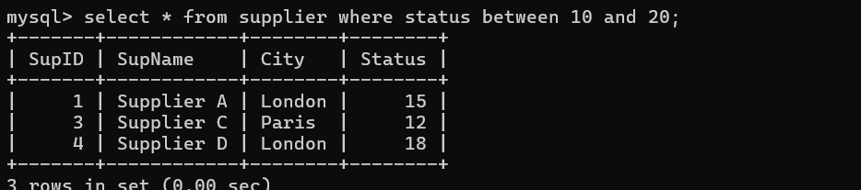

4. Display all the Parts and their Weight, which are not in the range of 10 and 15.

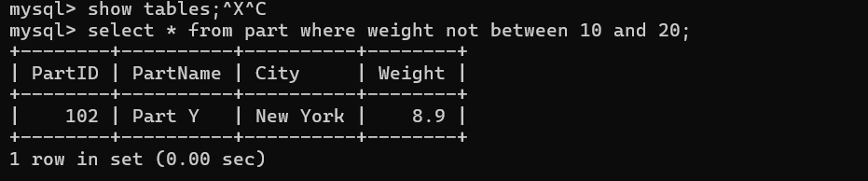

5. Display all the Part names starting with the letter ‘S’.

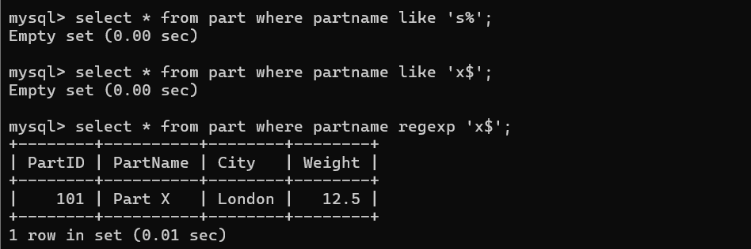

6. Display all the Suppliers, belonging to cities starting with the letter ‘L’.

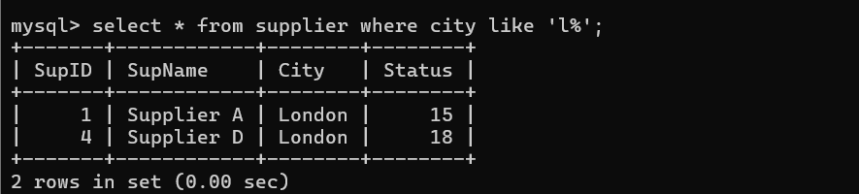

7. Display all the Projects, with the third letter in JNAME as ‘n’.

SQL Exercise 3

1. Display all the Supplier names with the initial letter capital.

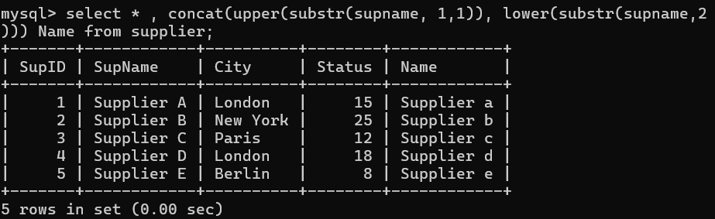

2. Display all the Supplier names in upper case.

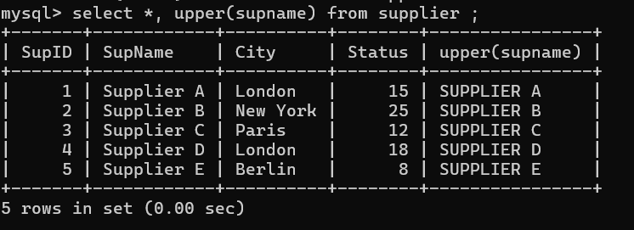

3. Display all the Supplier names in lower case.

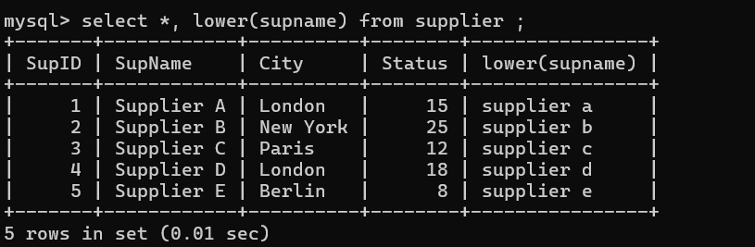

4. Display all the Supplier names padded to 25 characters, with spaces on the left.

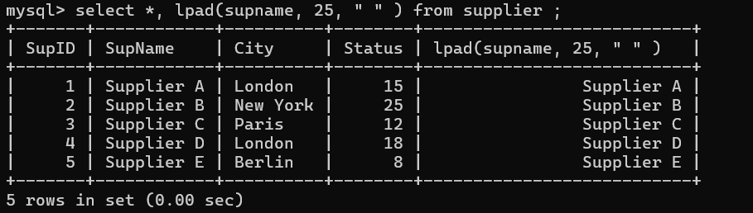

5. Display all the Supplier names (with ‘la’ replaced by ‘ro’).

HINT: REPLACE.

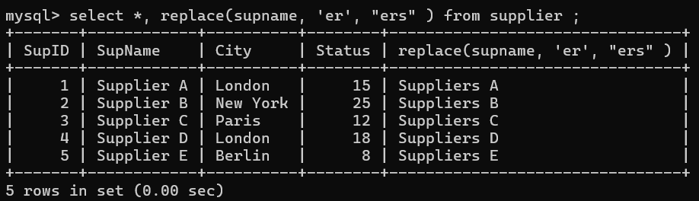

6. Execute the above command with the translate function and note the difference in

Output.

—->It replace all occurances of search string with new string replace er with ers.

7. Display the Supplier names and the lengths of the names.

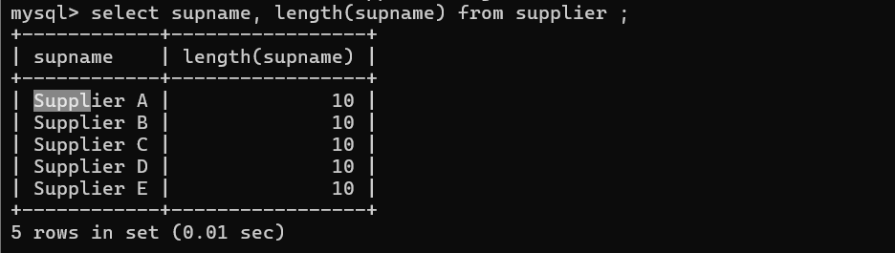

8. Use the soundex function to search for a supplier by the name of ‘BLOKE’.

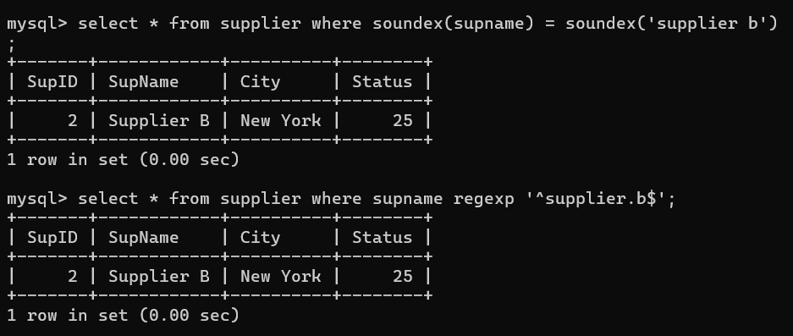

9. Display the Supplier name and the status (as Ten, Twenty, Thirty, etc.).

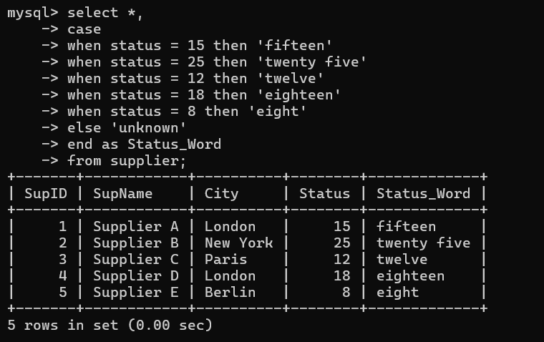

10. Display the current day (e.g. Thursday).

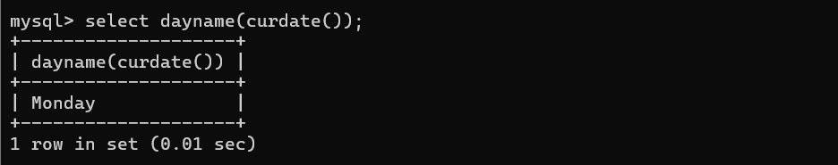

SQL Exercise 4

1. Display the minimum Status in the Supplier table.

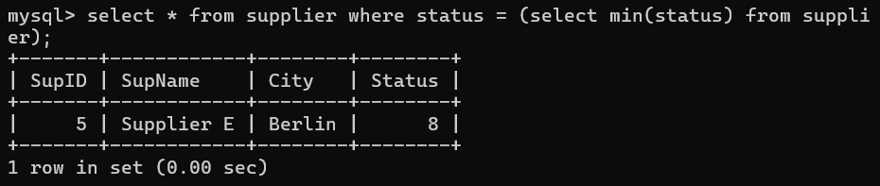

2. Display the maximum Weight in the Parts table.

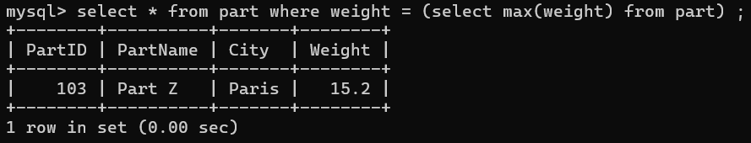

3. Display the average Weight of the Parts.

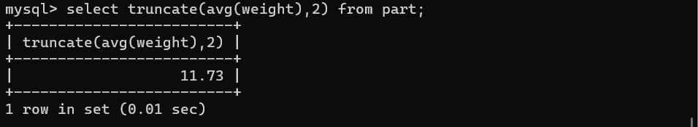

4. Display the total Quantity sold for part ‘P1’.

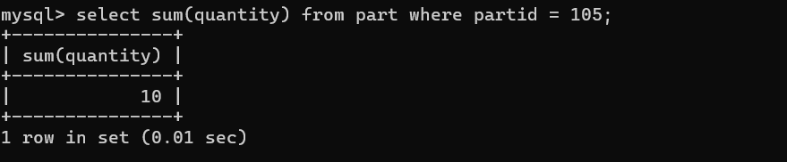

5. Display the total Quantity sold for each part.

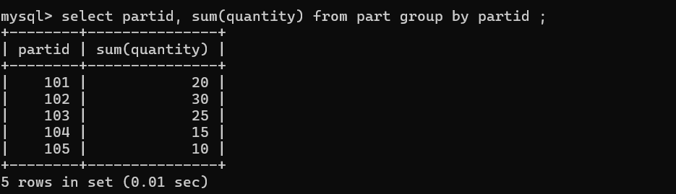

6. Display the average Quantity sold for each part.

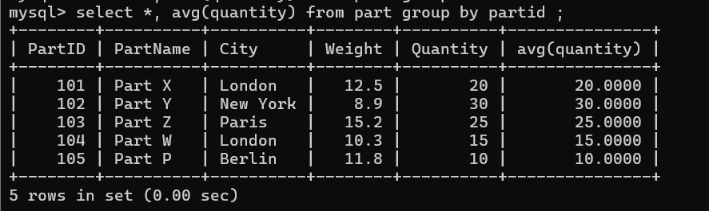

7. Display the maximum Quantity sold for each part, provided the maximum Quantity is

greater than 800.

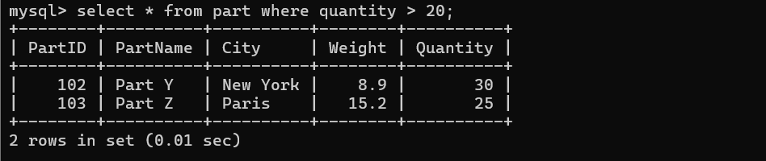

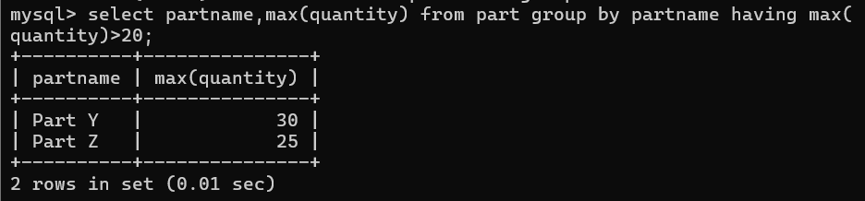

8. Display the Status and the count of Suppliers with that Status.

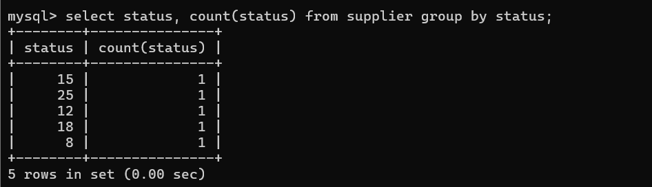

9. Display the count of Projects going on in different cities.

10. What is the difference between COUNT(Status) and COUNT(*) ?

the main difference between COUNT(*) and COUNT(column_name) is that COUNT(*) counts all rows in the result set, while COUNT(column_name) counts only the non-null values in the specified column

11. Display the Status and the Count of Suppliers with that Status in the following format

as shown below:-

Status Count

Ten 1

Twenty 2

Thirty 3

